BLG354E – Signals and Systems for CE Homework2
Şahin Olut - 150140124
1) Fourier series is important because in digital world we have limited space for storing informations. To store or process a file, we need the mathematical representation of file. Fourier transformation is doing it for us. Fourier transform allows us to simplify very difficult problems for analyzing.
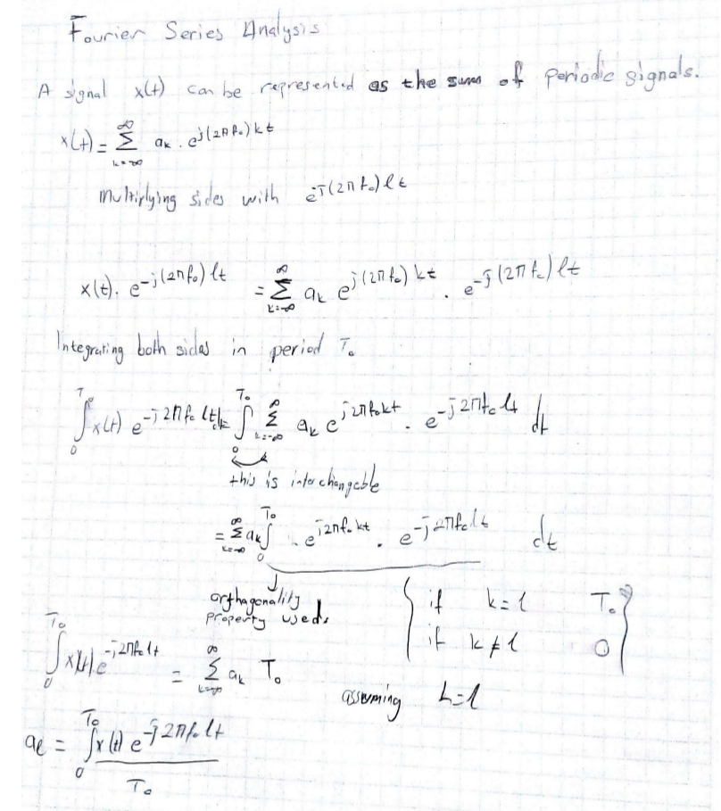

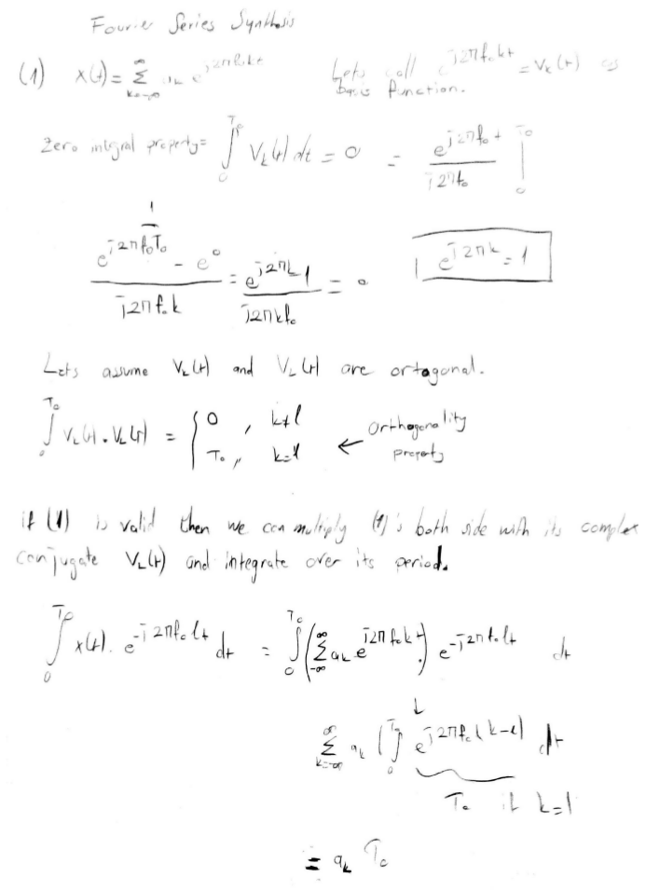

2) Orthogonality property is both used for analyzing and synthesing the Fourier Series. Without it, we can not say the result of integral in proof is equal to To.
3) Under Dirichlet conditions, periodic signals can be expanded to infinite set of complex exponents where frequencies are equal to +-k.f . If set has infinite elements, it turns out to be Fourier Transformation. Negative frequencies in Fourier Synthesis are similar to complex(imaginary) parts of signals. (Continuous-Time Signals, Springer, 2006)
4,5a)
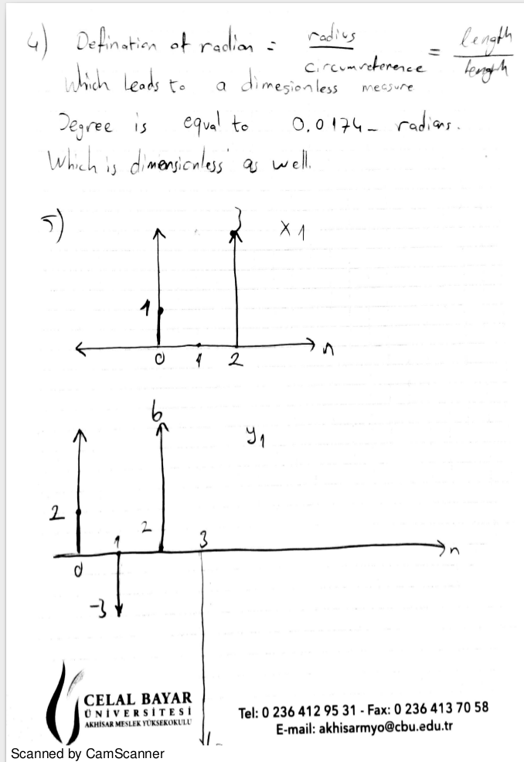

5b)
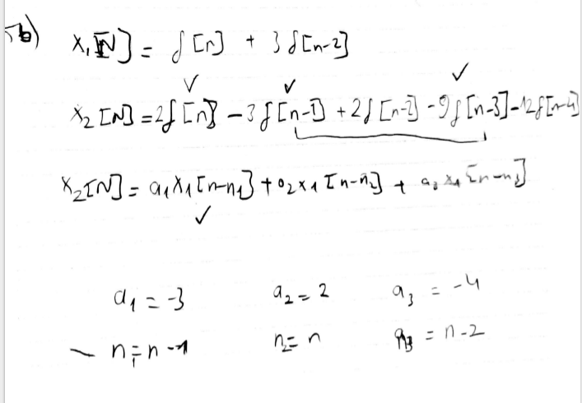

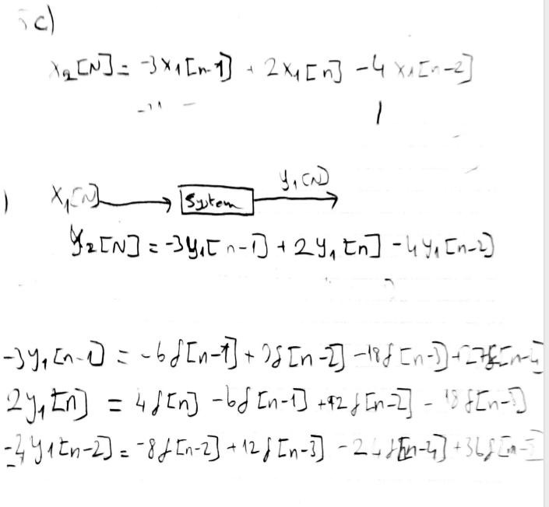
5c)

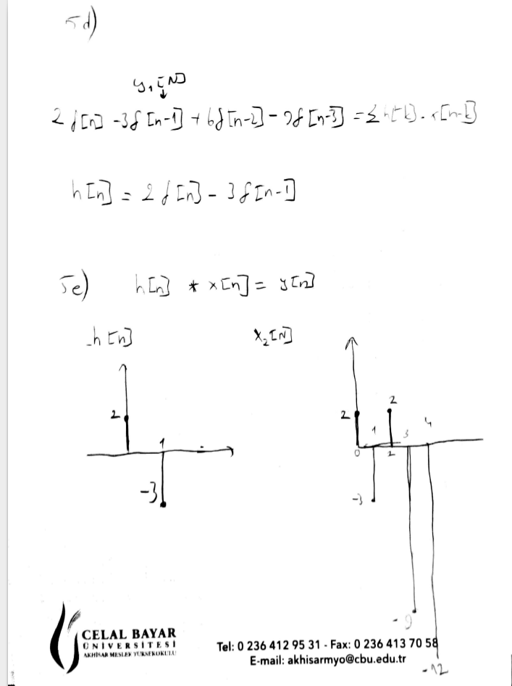
5d,e)

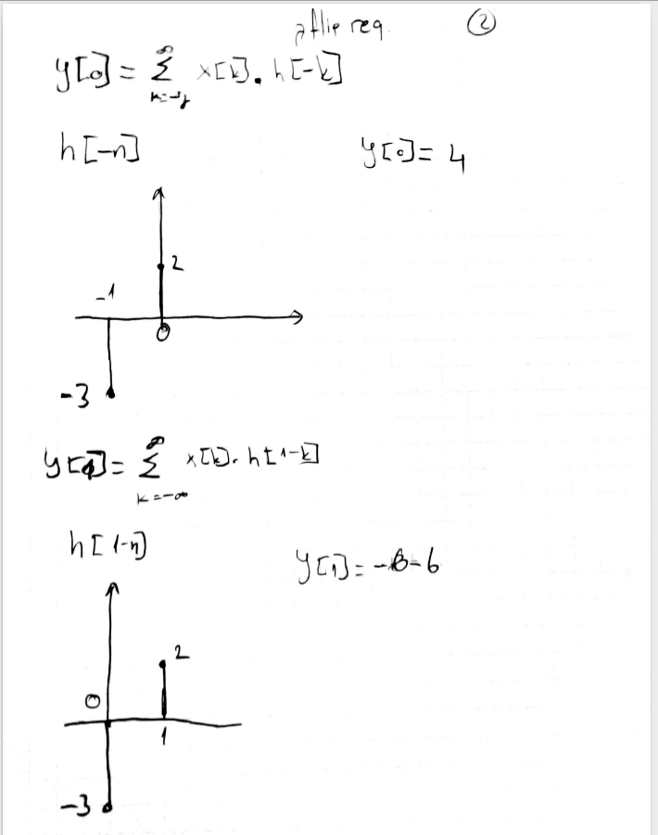

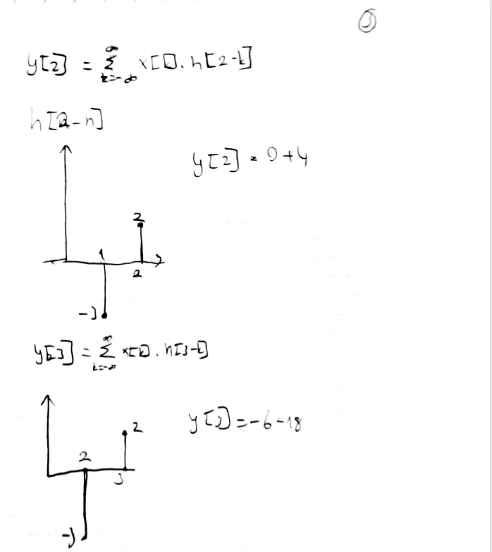

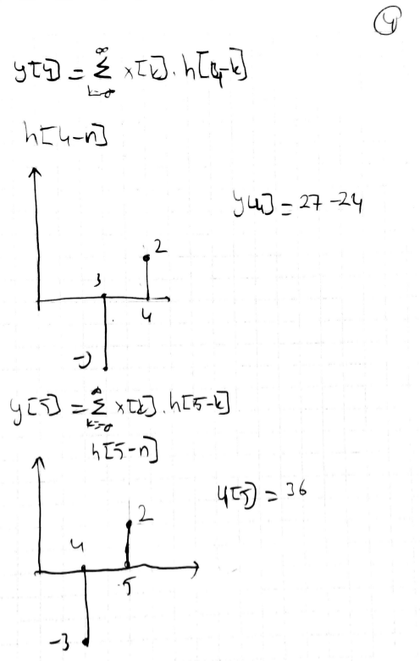

Y2 is equal to 4δ[n]+12δ[n-1]+13δ[n-2]-24δ[n-3]+3δ[n-4]+36δ[n-5]

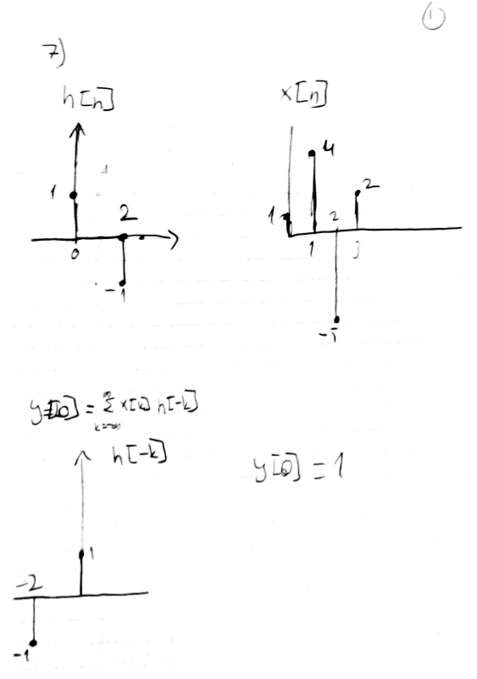
7)

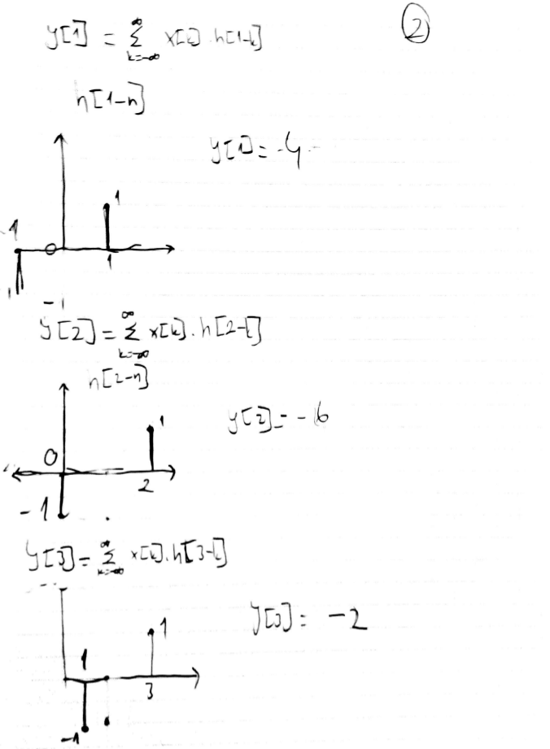

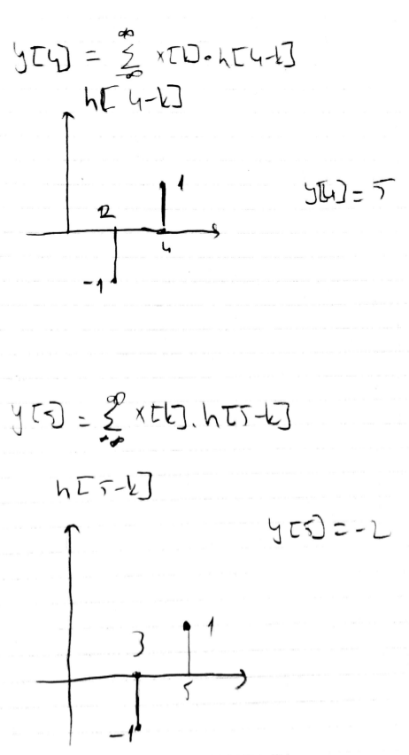

7b) h[n] = x[n] – x[n-2]
y[n] = δ[n] + 4δ[n-1] -6δ[n-2] -2δ[n-3] +5δ[n-4] -2δ[n-5]

7c) MATLAB code is provided in .zip file

REFERENCES USED IN HOMEWORK

1) Coursebook: Digital Signal Processing First
2) Continuous-Time Signals, Springer, 2006

